迁移步骤过程

# 新建用户

su - postgres -c "psql -c \"

CREATE USER dbadmin SUPERUSER PASSWORD 'Siemens@Tcm@2023';

CREATE USER infodba SUPERUSER PASSWORD 'Siemens@Tcm123';

CREATE USER replica PASSWORD '123456' REPLICATION;

CREATE USER pgrewind SUPERUSER PASSWORD '123456';

\" "

# 新建表空间

infodba_idate /data01/pgsql/tc/infodba_idata

infodba_ilog /data01/pgsql/tc/infodba_ilog

infodba_indx /data01/pgsql/tc/infodba_indx

tcclusterdb_idata /data01/pgsql/tc/tcclusterdb_idata

CREATE TABLESPACE infodba_idate LOCATION '/data01/pgsql/tc/infodba_idata';

CREATE TABLESPACE infodba_ilog LOCATION '/data01/pgsql/tc/infodba_ilog';

CREATE TABLESPACE infodba_indx LOCATION '/data01/pgsql/tc/infodba_indx';

CREATE TABLESPACE tcclusterdb_idata LOCATION '/data01/pgsql/tc/tcclusterdb_idata';

# 新建库

su - postgres -c "psql -c \"CREATE DATABASE tc WITH owner infodba encoding 'UTF8' template template0 LC_COLLATE='C' ;\""

create user TcClusterDB password 'tcclusterdb';

create tablespace TcClusterDB_idata owner TcClusterDB location '/data01/pgsql/tc/tcclusterdb_idata';

create database TcClusterDB with owner TcClusterDB encoding 'UTF8' template template0 lc_collate 'C' tablespace TcClusterDB_idata;

grant all privileges on database TcClusterDB to TcClusterDB;

grant CREATE ON TABLESPACE TcClusterDB_idata to TcClusterDB;

3.--新建schema

--su - postgres -c "psql -d bopdrill -c \"CREATE SCHEMA infodba;\" "

# 使用flashsync导表结构

4.1创建传输任务

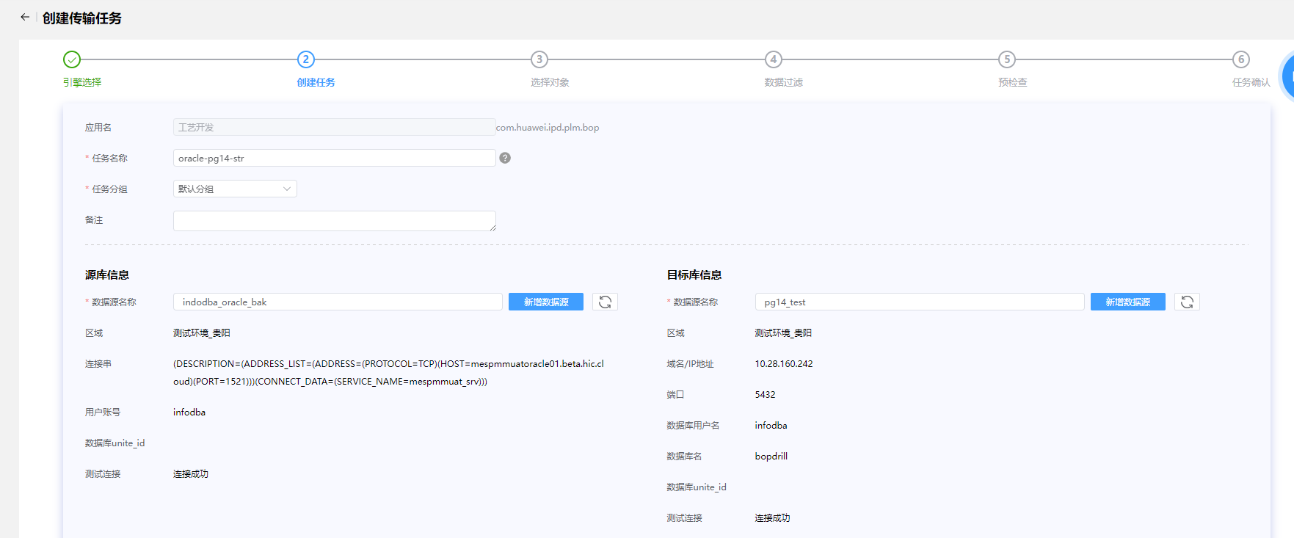

4.2添加schema列表或者Table列表（数据搬迁）

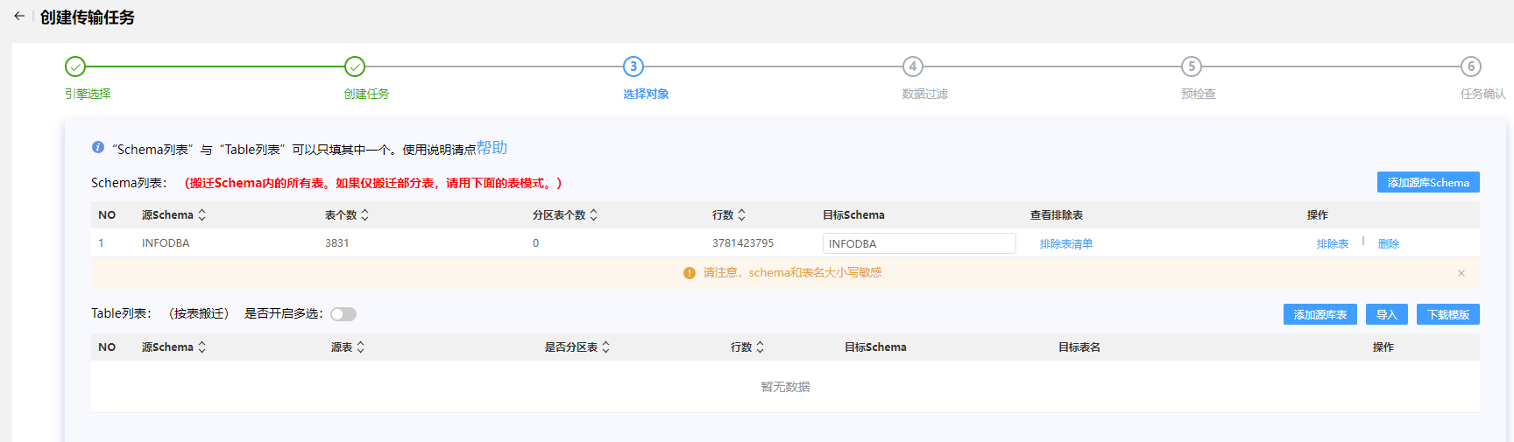

排除表（MMV_SPATIAL_CELL_INDEX、TEMP_SESSION、TEMP_SESSION_0618、TEMP_SESSION_0619_1）

4.3数据过滤

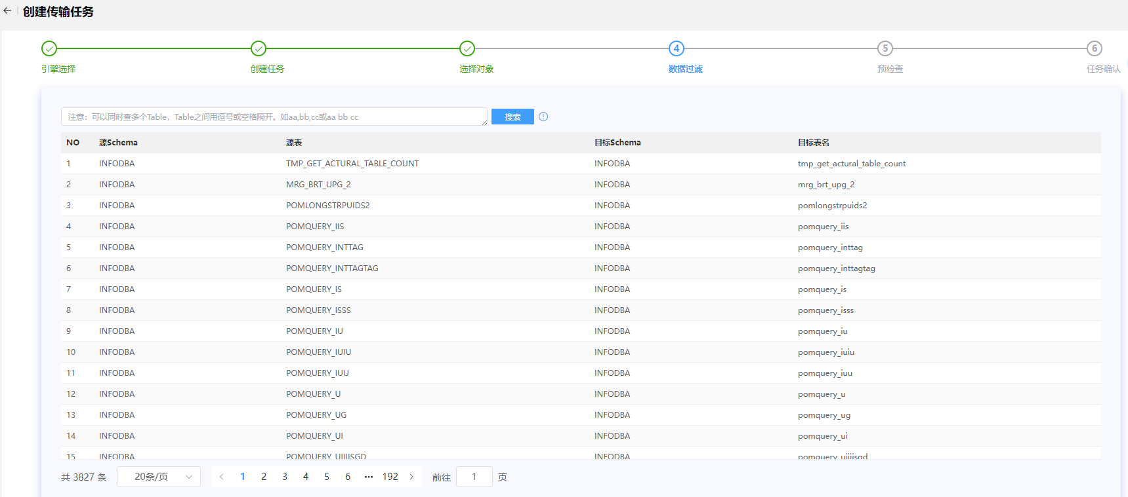

4.4预检查

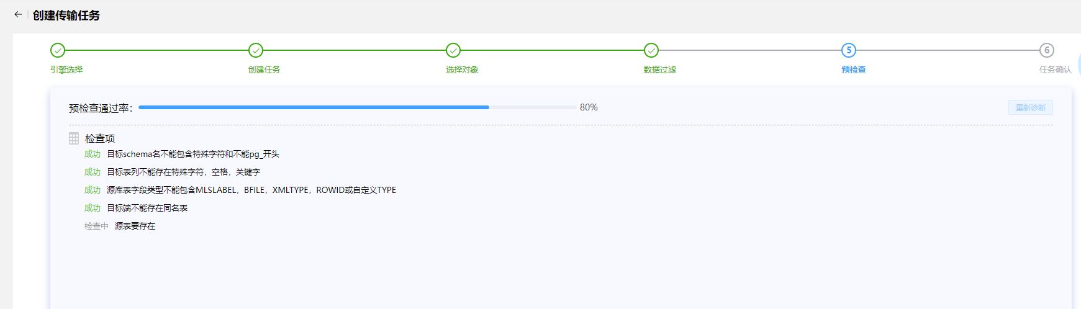

4.5任务确认

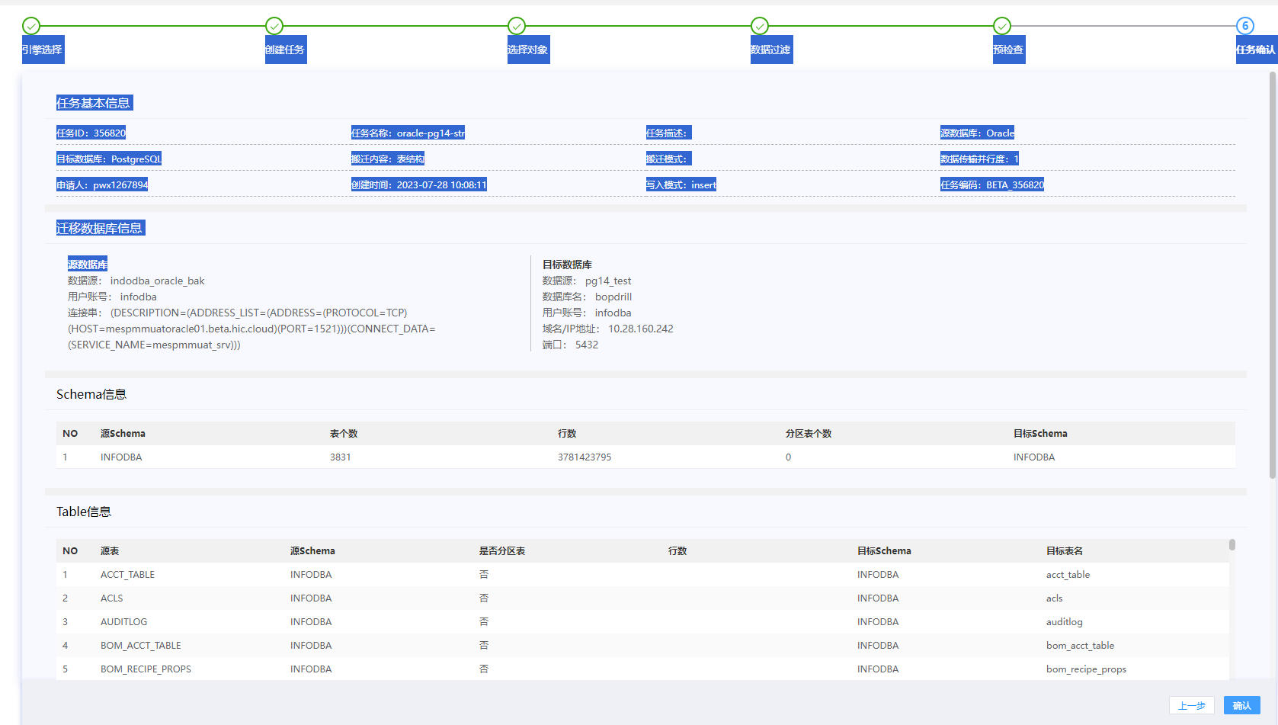

时长：25分32秒

5.新建排除4张的表结构

create table MMV_SPATIAL_CELL_INDEX

(

puid VARCHAR(15) not null,

spatial_rep VARCHAR(15) not null,

cell_id INTEGER not null,

occ_path_prefix VARCHAR(900) not null,

occ_path_suffix VARCHAR(4000),

pxmin numeric,

ymin numeric,

zmin numeric,

pxmax numeric,

ymax numeric,

zmax numeric

);

create unique index MMVSPATIALCELLINDEX_PUID_PK on MMV_SPATIAL_CELL_INDEX (PUID);

create index MMV_SPATIAL_CELLID1 on MMV_SPATIAL_CELL_INDEX (CELL_ID);

create index MMV_SPATIAL_OCCPATHPREFIX1 on MMV_SPATIAL_CELL_INDEX (OCC_PATH_PREFIX);

create index MMV_SPATIAL_SPATIALREP1 on MMV_SPATIAL_CELL_INDEX (SPATIAL_REP);

create table TEMP_SESSION

(

id numeric,

exetime DATE,

sid numeric,

"serial#" numeric,

process VARCHAR(24),

machine VARCHAR(64),

program VARCHAR(48),

osuser VARCHAR(30),

status VARCHAR(8),

prev_sql_id VARCHAR(24),

sql_id VARCHAR(24)

);

create table TEMP_SESSION_0618

(

id numeric,

exetime DATE,

sid numeric,

"serial#" numeric,

process VARCHAR(24),

machine VARCHAR(64),

program VARCHAR(48),

osuser VARCHAR(30),

status VARCHAR(8)

);

create table TEMP_SESSION_0619_1

(

id numeric,

exetime DATE,

sid numeric,

"serial#" numeric,

process VARCHAR(24),

machine VARCHAR(64),

program VARCHAR(48),

osuser VARCHAR(30),

status VARCHAR(8),

prev_sql_id VARCHAR(24),

sql_id VARCHAR(24)

)

6.导入四张表的数据，MMV_SPATIAL_CELL_INDEX、TEMP_SESSION、TEMP_SESSION_0618、TEMP_SESSION_0619_1 （flashsync)

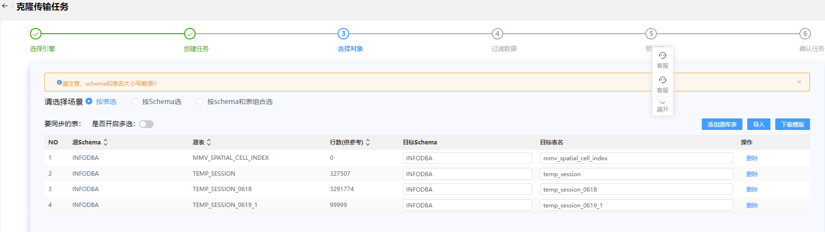

7.导入所有表的数据除MMV_SPATIAL_CELL_INDEX、TEMP_SESSION、TEMP_SESSION_0618、TEMP_SESSION_0619_1 （flashsync)。

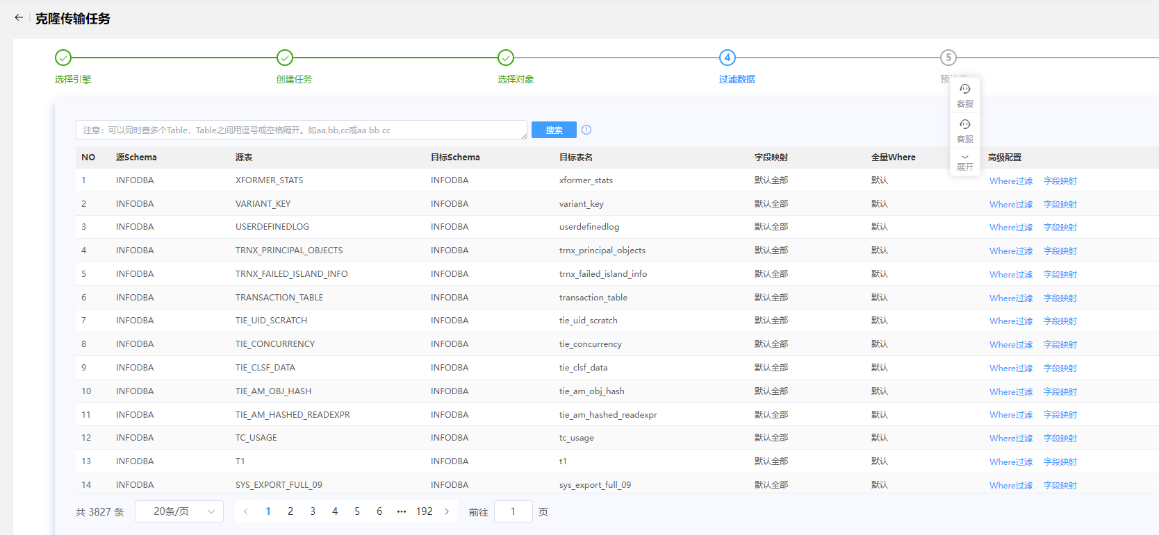

索引重建报错：rebuild index piph6specialoperationreq_0 error,error:index row size 2808 exceeds btree version 4 maximum 2704 for index "piph6specialoperationreq_0" DETAIL: Index row references tuple (8386,36) in relation "ph6specialoperationreq". HINT: Values larger than 1/3 of a buffer page cannot be indexed. Consider a function index of an MD5 hash of the value, or use full text indexing.

解决方案：

create extension pg_trgm;

create index ph6specialoperationreq_0 on ph6specialoperationreq using gin (PVAL_0 gin_trgm_ops);

create index ph6notice1_0 on ph6notice1 using gin (PVAL_0 gin_trgm_ops)

安装插件create extension pg_trgm;报错信息是extenction文件目录中缺少control文件。应该是编译信息没有遍全

( tar -zxvf postgresql-14.8.tar.gz -C /app/install

cd /app/install/postgresql-14.8

./configure –prefix=/app/postgresql

make world && make install-world)

8.大概对比数据量oracle迁移到PG

8.1对比表数据

Oracle:

select count(*) from user_tables; 3831

Pg14:

SELECT COUNT(*) AS table_count

FROM information_schema.tables

WHERE table_schema = 'public' and table_type = 'BASE TABLE; 3831

8.2视图数据

Oracle:

Select count(*) from user_views; 283

Pg14:

SELECT table_name

FROM information_schema.views

WHERE table_schema = current_schema; 0

8.3索引数据

oracle:

select index_name as indexname from user_indexes i where i.index_name not like ‘SYS_%’; 6660

pg:

select upper(indexname) from pg_indexes where schemaname = ‘infodba’ and not like ‘sys_%’; 6656

select index_name as indexname from user_indexes i where i.index_name not like ‘SYS_%’ except select upper(indexname) from pg_indexes where schemaname = ‘infodba’ and not like ‘sys_%’; 结果为

INDEXNAME

MMV_SPATIAL_CELLID1

MMVSPTIALCELLINDEX_PUID_PK

MMV_SPATIAL_SPATIALREP1

PIPOM_BACKPOINTER2

MMV_SPATIAL_OCCPATHPATHPREEIX1

PIPH6SPECIALOPERATIONREQ_0

Select * from user_indexes i where i.index_name not like ‘SYS_%’ and table_name=’MMV_SPATIAL_CELL_INDEX’;

MMV_SPATIAL_CELLID1

MMVSPTIALCELLINDEX_PUID_PK

MMV_SPATIAL_SPATIALREP1

MMV_SPATIAL_OCCPATHPATHPREEIX1

PIPOM_BACKPOINTER2

辅助SQL语句（Select * from user_indexes i where i.index_name not like ‘SYS_%’ and table_name=’MMV_SPATIAL_CELL_INDEX’;

Select * from user_indexes i where i.index_name not like ‘SYS_%’ and index_name=’PIPOM_BACKPOINTER2’;）

create index PIPOM_BACKPOINTER2 on pom_backpointer (to_uid);

create index PIPH6SPECIALOPERATIONREQ_0 on ph6specialoperationreq(pval_0);

问题

创建PIPH6SPECIALOPERATIONREQ_0报错

Error:index row size 2808 exceeds btree version 4 maximum 2704 for index”piph6specialoperationreq_0”

DETAIL:Index row references tuple(838636) in relation “ph6specialoperationreq”

HINT:values larger than 1/3 of a buffer page cannot be indexed.

8.4序列数据

oracle:

SELECT count(*) FROM user_sequences; 310

pg：

SELECT count(*)

FROM information_schema.sequences

WHERE sequence_schema = current_schema; 0

8.5对比约束。

9.迁移其它对象

9.1导出约束

Vi ora2pg.conf

--修改内容如下

TYPE TABLE

Ora2pg -c /data01/soft_tar/export_dir/ora2pg.conf -o /data01/soft_tar/export_dir/test1/output.sql > /data01/soft_tar/export_dir/test1/output.sql

产生的 output.sql 文件用 table_split.pl 处理下，将table的创建语句和constraint，index的创建语句分开。

table_split.pl 内容如下

----------------------------------------------------------------------------------------------------------------------

open(INPUT, "output.sql");

open(OUTPUT, ">", "table.sql");

open(OUTPUT2, ">", "constraints.sql");

open(OUTPUT3, ">", "index.sql");

while(<INPUT>){

$str.=$_

}

@index=$str=~/CREATE\s*(?:UNIQUE)?\s*INDEX\s+\w+\s+ON[^\n]*;\n/igm;

@constraint=$str=~/ALTER\s*TABLE[^\n]*;\n/igm;

$str=~s/CREATE\s*(?:UNIQUE)?\s*INDEX\s+\w+\s+ON[^\n]*;\n//igm;

$str=~s/ALTER\s*TABLE[^\n]*;\n//igm;

print OUTPUT3 @index;

print OUTPUT2 @constraint;

导入约束

psql -U infodba -d infodba_test -f constraints.sql > constraints_output.log 2>&1

grep ‘psql’ constraints_output.log

psql:constraints.sql:53:ERROR:cannot alter system column “xmin”

psql:constraints.sql:56:ERROR:cannot alter system column “xmin”

alter table mmv_spatial_cell_index alter column pxmin set not null;

alter table mmv_spatial_cell_index alter column pxmax set not null;

9.2序列

Vi ora2pg.conf

--修改内容如下

TYPE SEQUENCE

ora2pg -c /data01/soft_tar/export_dir/ora2pg.conf -o /data01/soft_tar/export_dir/test1/sequence.sql > /data01/soft_tar/export_dir/test1/sequence.sql

导入

psql -U infodba -d infodba_test -f sequence.sql > sequence_output.log 2>&1

查看oracle序列个数：select count(*) from user_sequences; 310

查看PG序列个数：select count(*) from information_schema.sequences where sequence_schema =CURRENT_SCHEMA; 310

9.3视图

Vi ora2pg.conf

--修改内容如下

TYPE VIEW

ora2pg -c /data01/soft_tar/export_dir/ora2pg.conf -o /data01/soft_tar/export_dir/test1/view.sql > /data01/soft_tar/export_dir/test1/view.sql.log

导入

psql -U infodba -d infodba_test -f view.sql > view_output.log 2>&1

grep “psql” view_output.log

psql:view.sql:744: ERROR: function lpad(bigint,integer,unknown) does not exist

psql:view.sql:892: ERROR: function lpad(bigint,integer,unknown) does not exist

psql:view.sql:1116: ERROR: function lpad(bigint,integer,unknown) does not exist

解决方案：

CREATE OR REPLACE FUNCTION pg_catalog.lpad(bigint, integer, varchar)

RETURNS text

LANGUAGE sql

IMMUTABLE STRICT

AS $function$

SELECT pg_catalog.lpad($1::text, $2, $3::text)

$function$

CREATE OR REPLACE VIEW vl10n_einfo (puid, locale, preference, status, sequence_no, pval_0) AS SELECT puid, SUBSTR(pval_0,1,5) as locale, SUBSTR(pval_0,7,1) as preference, SUBSTR(pval_0,9,1) as status, SUBSTR(pval_0,11,4) as sequence_no, SUBSTR(pval_0,49,240) as pval_0 FROM PL10N_EINFO

UNION ALL

SELECT PEINFO.puid, 'NONE' as locale, 'M' as preference, 'M' as status, pg_catalog.lpad(pseq, 4, '0') as sequence_no, pval_0 FROM PEINFO, PICML WHERE PICML.puid=PEINFO.puid AND PICML.VLA_487_5=0;

CREATE OR REPLACE VIEW vl10n_awp0contentnames (puid, locale, preference, status, sequence_no, pval_0) AS SELECT puid, SUBSTR(pval_0,1,5) as locale, SUBSTR(pval_0,7,1) as preference, SUBSTR(pval_0,9,1) as status, SUBSTR(pval_0,11,4) as sequence_no, SUBSTR(pval_0,49,128) as pval_0 FROM PL10N_AWP0CONTENTNAMES

UNION ALL

SELECT PAWP0CONTENTNAMES.puid, 'NONE' as locale, 'M' as preference, 'M' as status, lpad(pseq, 4, '0') as sequence_no, pval_0 FROM PAWP0CONTENTNAMES, PAWP0TILETEMPLATE WHERE PAWP0TILETEMPLATE.puid=PAWP0CONTENTNAMES.puid AND PAWP0TILETEMPLATE.VLA_1310_9=0;

CREATE OR REPLACE VIEW vl10n_value (puid, locale, preference, status, sequence_no, pval_0) AS SELECT puid, SUBSTR(pval_0,1,5) as locale, SUBSTR(pval_0,7,1) as preference, SUBSTR(pval_0,9,1) as status, SUBSTR(pval_0,11,4) as sequence_no, SUBSTR(pval_0,49,256) as pval_0 FROM PL10N_VALUE

UNION ALL

SELECT PVALUE.puid, 'NONE' as locale, 'M' as preference, 'M' as status, lpad(pseq, 4, '0') as sequence_no, pval_0 FROM PVALUE, PSTXT WHERE PSTXT.puid=PVALUE.puid AND PSTXT.VLA_491_19=0;

查看oracle视图数量：select count(*) from user_views; 283

查看pg视图数量：select count(*) from information_schema.views where table_schema = CURRENT_SCHEMA; 283

9.4过程

Vi ora2pg.conf

--修改内容如下

TYPE PROCEDURE

ora2pg -c /data01/soft_tar/export_dir/ora2pg.conf -o /data01/soft_tar/export_dir/test1/procedure.sql > /data01/soft_tar/export_dir/test1/procedure.sql.log

导入

psql -U infodba -d infodba_test -f procedure.sql > procedure_output.log 2>&1

grep ‘psql’ procedure_output.log

psql:procedure.sql:59:ERROR: syntax error at or near “dbms_stats”

9.5函数

Vi ora2pg.conf

--修改内容如下

TYPE FUNCTION

ora2pg -c /data01/soft_tar/export_dir/ora2pg.conf -o /data01/soft_tar/export_dir/test1/function.sql > /data01/soft_tar/export_dir/test1/function.sql.log

导入

psql -U infodba -d infodba_test -f function.sql > function_output.log 2>&1

ERROR:syntax error at or near “IS”

LINE 13:TYPE lookup_decision_map IS TABLE OF BOOLEAN INDEX BY VARCHAR

CONTEXT:invalid type name “lookup_decison_map IS TABLE OF BOOLEAN INDEX BY VARCHAR(500);

函数tc_configure_cnf(cnf varchar)导入报错。

对比函数

Oracle查看函数：

9.6触发器

Vi ora2pg.conf

--修改内容如下

TYPE TRIGGER

ora2pg -c /data01/soft_tar/export_dir/ora2pg.conf -o /data01/soft_tar/export_dir/test1/trigger.sql > /data01/soft_tar/export_dir/test1/trigger.sql.log

导入

psql -U infodba -d infodba_test -f trigger.sql > trigger_output.log 2>&1

报错

Psql:trigger.sql:8 NOTICE:trigger “fast_sync_add_trigger” for relation “ppom_object” does not exist,skipping

Psql:trigger.sql:24 NOTICE:trigger “fast_sync_delete_trigger” for relation “ppom_object” does not exist,skipping

触发器用初始化库的，因为初始化库包含了。

9.7包

Vi ora2pg.conf

--修改内容如下

TYPE PACKAGE

ora2pg -c /data01/soft_tar/export_dir/ora2pg.conf -o /data01/soft_tar/export_dir/test1/package.sql > /data01/soft_tar/export_dir/test1/package.sql.log

导入

psql -U infodba -d infodba_test -f package.sql > package_output.log 2>&1

二部分 对比数据定义的int

* + - 1. 导出所有int字段

PG：select table_name,column_name,data_type,udt_name from information_schema.columns where table_schema = ‘infodba’ and udt_name like ‘int%’;

* + - 1. oracle迁移到PG的字段int
      2. PG初始化的数据库的字段int
      3. Oracle迁移到PG与PG初始化相同的int字段
      4. Oracle迁移到PG与PG初始化不同的int字段

三部分 把PG初始化的对象在迁移过来没有的放入到迁移库中

1. 表的迁移
2. 索引迁移
3. 约束迁移
4. 序列迁移
5. 视图的迁移
6. 函数的迁移
7. 存储过程的迁移

8.触发器的迁移